Xbox Controller Test Disc Instructions v. 0.8

- Copy Controller Test ver x.x.iso file onto a blank CD-RW disc (if disc not supplied).

- Insert Controller Test disc into Xbox console and reboot machine.

- ControllerTest2: dual expansion slot controller

ControllerTest1: single expansion slot controller
ControllerTest0: no expansion slot controller
Production level testing for Xbox-compatible controllers (including wheels and other subtypes).
To successfully complete the test, go through the flashing component of the controller.
Order: (ControllerTest2 example)

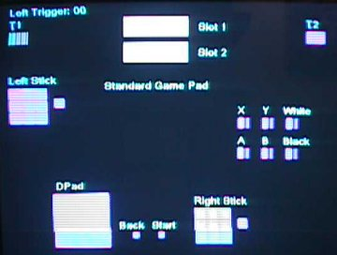

- Pull left trigger to max; trigger must report values in zones and motor must rumble.
- Release left trigger; trigger must return to 0×00 and motor must stop.
- Pull right trigger to max; trigger must report values in zones and motor must rumble.
- Release right trigger; trigger must return to 0×00 and motor must stop.
- Insert memory unit into slot 1; green indicates enumeration.
- Insert memory unit into slot 2; green indicates enumeration.
- Move left thumbstick in a counter clockwise direction; thumbstick must report values in all nine zones.
- Press left thumbstick button.
- Press D-pad in counter-clockwise direction; D-pad must report all nine values.
- Press BACK button.
- Press START button.
- Move right thumbstick in a counter clockwise direction; thumbstick must report values in all nine zones.
- Press right thumbstick button.
- Press analog buttons in order of X, Y, White, A, B, Black; all buttons must reach max, min, and report values in different ranges.

- GamePad1: Application used for testing various features of the controller (including steering wheels and other subtypes).
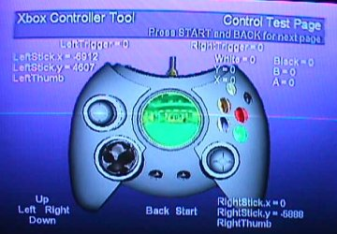
Press START + BACK to move to next screen.

- Screen 1: Tests operation of various controller functions.
- Screen 2: Rumble test page.
- Screen 3: Deadzone calibration for thumbsticks.
- Screen 4: Control Quantization Page; tests precision of analog buttons and thumbsticks.
All features must work. Power cycle to return to test launch menu.

- MURW: Memory Unit Read Write

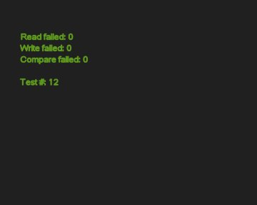
- Write read test of the hub to the memory unit (MU).
- Insert MU in upper, and then lower slots.
- No failures equals passing.
- Refer to Xbox Compatibility Test List for cycles required to pass compatibility testing.
- Power cycle to return to test launch menu.

- MUTGen: Memory Unit Traffic Generator

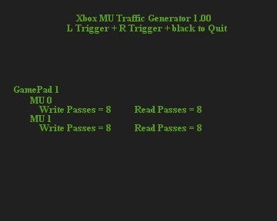
- Generates high bandwidth of 10 megabits traffic through MU.
- Insert MU in upper, and then lower, and then both slots.
- Read passes should equal write passes.
- Refer to Xbox Compatibility Test List for cycles required to pass compatibility testing.
- Power cycle to return to test launch menu.

- REENUM – Software Plug and Unplug Test
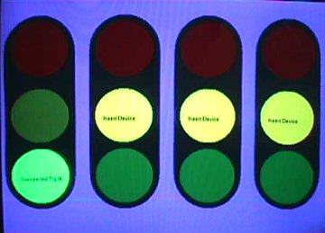
- Insert controller into any controller port (or multiple ports).
- Yellow light will change to green light and display Successful Try: xx
- Refer to Xbox Compatibility Test List for cycles required to pass compatibility testing.
- Power cycle to return to test launch menu.

